# Application form for STW under RIDF

(To be filled by official)

# Serial No:

Date of submission:

Sign of receiving official:

**Annexure** — II

To

One copy of recent passport size self- attested photo of applicant must be pasted here

The EE (A) / AEE (A),

, **District** ....

I, Shri/Smt. . . . . . . . . . . . . . . . .. . .. . . . . . . . . . .. . .. . . . . . . . . . . . . . . . . .. . ... ... . . . . . .. . . . . . . . . . . .. .. .., (Name of applicant i.e.

individual farmer or group leader). furnished the following information for allotment of one No. of following type of STW.

1. Type of STW applied for (V mark where **applicable):**

|  |  |
| --- | --- |
| Type of STW | mark |
| 1 . STW with Diesel Centrifugal Pump-set (Type of Pumpset ) |  |
| 2. STW with Electrical Centrifugal Pump-set(Type of Pumpset ) |  |
| 3. STW with Electrical Submersible Pump-set(Type of Pumpset ) |  |
| 4. STW with SPV Water Pumping System consisting of Surface Pump (Type of Pumpset ) |  |
| 5. STW with SPV Water Pumping System consisting of Submersible Pump (Type of Pumpset ) |  |

1. Address of applicant (individual farmer or group leader):

|  |  |  |  |  |  |  |  |
| --- | --- | --- | --- | --- | --- | --- | --- |
| Village:. | |  |  | Block: | |  |  |
| PO |  |  |  | PS. |  |  |  |
| LAC: | |  |  | GP: |  |  |  |
| Mobile No: | |  |  | Email ID: | |  |  |
| . Ban k Account derails of **applicant** (individual **farmer or group leader):** | | | | | | | |
| Bank Account No.: | | |  | IFSC Code: | |  |  |
| Bank Branch: | |  |  | Name of Bank: | |  |  |
| . Detail of Land (of individual farmer or all farmers of the group **applied for tbe STW):** | | | | | | | |
| SN | Name of farmer(s) | *SC/ST/ Women | Father's/ husband Name | Voter ID No. | Cultivable area for  proposed STW (bigha) | Present cropping pattern | Proposed cropping pattern |
|  |  |  |  |  |  |  |  |
|  |  |  |  |  |  |  |  |
|  |  |  |  |  |  |  |  |
|  |  |  |  |  |  |  |  |
|  |  |  |  |  |  |  |  |
|  |  |  |  |  |  |  |  |
|  | | Total | | |  |  |  |



3



4

Page 12 of 53



|  |  |
| --- | --- |
| Self finance | Bank Loan |
|  |  |

i›. **Kishan Credit Card details:**

|  |  |  |
| --- | --- | --- |
| KCC No. & date | Bank | Branch |
|  |  |  |

7. Self attested copies **of following documents are to be** submitted along with the **application:**

|  |  |  |
| --- | --- | --- |
| SN | Documents to be submitted | Yes/No |
| 1. | Copy of Voter ID (EPIC)/ Aadhar |  |
| 2. | Copy of Land holding certificate or Title deed or Jamabandi or Land  Possessing certificate from Gaon Burha or Moujadar as proof of ownership of cultivable area for proposed STW in the name of applicant farmer(s). (For land shown in Column-6 of Point-4) |  |
| 3. | Copy of caste Certificate for SC/ST farmers from appropriate authority. |  |
| 4. | Copy of KCC (if any) |  |
| 5. | One copy of recent passport size photo of applicant. |  |
| 6. | Bank Draft NO. of Rs.10000.00 (Rupees  Ten Thousand only) in favour of supplier .................................... as advance payment (in case of SPV Pumpset) |  |
| 7. | For cluster basis of Rs. 2500.00m(Rupees Two thousand **Five** hundred  only)/ Rs (NSC/FD/Call Deposit) as security deposit. |  |

*All the information and statements furnished* iii/wif/t *this application by ziie/us are true and I/we accept thai any misinterpretation contaiited in it may lead to my/ our disqualification. I/ We understa*n*d that decision of aCCOFding approval or rejection of my/ our application shall be binding on me/ us.*

**Place:**

**Date:**

**Signature of the Applicant**

(Individual farmer or group leader)

*This is to certify that the applicant La) group of far*m*ers, tb) individual farmer, (c) individual farmer wiih adjacent farrier is/are identified and information and statements furnished in/with this application are verified us irue. They proposal is fo*ri*vardeJ* fo f/ie *EE (A) / AEE (A)...... ... ... ... ... ... ...through NGO for consideration.*

(Seal **& Signature** of Rep. of District NGO), (Seal & Signature of AEA), (Seal & Signature of BE) Check **by ADO** ( Seal & Signature) and Forward to **EE(A)/AEE(A) for consideration.**

Date:

Place:



Page 13 of 53

Pass-port size photograph of ndivldual farme group of farmers

Format for Undertakin for Installation of SiialioThe Well under RIDF

Sri/Sm name individual farmer group leader) solemnly giving the following undertakings on /. /2018, for availing subsidy for installation of one

Shallow T Diesel/ Electrical Pump-set/ SPV water Pumping System) under RIDF, which will be binding on me and any violation of these, will penalize me for legal action and or action as decided by the Department of Agriculture, Assam.

This Undertaking is made for the purpose to develop Irrigation facility for increasing production and productivity

2. I/we understood 50'X of installation cost of SM and 50‘X• of cost of Diesel/ Electrical Pump-set or85% of the cost of Solar PV pumping system and storage tank, limited to maximum admissible subsidy will be borne by the Agriculture Department, and rest of the total cost of the STW shall be borne by me / us from self resources or Bank loan.

I/We enclose herewith an undertaking for optimum utilisation of STW water for irrigation in the adjacent plot of agriculture land, with the participating group members duly signed by individual member.

4. I/we will abide by the ”Guideline for Installation of STW under Projects - ”Installation of 1 Lakh Shallow Tube “1000 Solar PV Powered STW” under RIDF”, which is annexed with this Undertaking.

S. As soon as I/we receive Sanction Order from EE(A), I/we shall proceed for installation of SM/ construction of storage tank as per plan and estimate by self/ through empanelled contractor and procurement of Pump-set / construction of storage tank as per approved specification under supervision of technical officers of Agriculture Department and complete within IO days and commission the STW within 15 days from the date of issue of the sanction order, and I / we understand that failing to do so this sanction order will automatically lapse. I / we also understand that additional 20 days only be allowed in case I / we opted for bank loan.

1. I/we understood that insurance of the Pump-set/SPV system is mandatory Ind l will abide by this.
2. l/we shall bear the cost of operation and maintenance of the SM and Pump-set/SPV system
3. I/we shall properly & efficiently utilise irrigation water available from the SM and allow nearby farmers to derive the.

benefit or all the members of the group can derive the benefit.

1. I/we will not sell or transfer the Pump-set/SPV system to any other party during the service period of Pump-set.
2. l/we understand that Officials of the Agriculture Department, or any other agency authorized by the Agriculture Department, shall have the right to inspect the STW & Pump-set at any time to ensure its utilizat on and take action for illegal utilization or loss.
3. I/we shall be responsible for any damage, loss and theft of the Pump-set.
4. I/we shall maintain proper log book and utilization register as prescribed by the Agriculture Department for inspection of the same at any time.
5. I/we understand that any dispute between me / us and the Agriculture Department will be resolved amicably by the Directorate of Agriculture, Khanapara, Guwahati-781022.
6. I/we fully understand that any violation of clauses enumerated above will penalize me/us for legal action and or action as decided by the Department of Agriculture, Assam and put my/ our signature below in my/our good state of mind(s) in presence of following witnesses.
7. Optional:- I/We like to pray for arranging **a contractor from the departmental approved empanelled list to execute the** STW/water storage tank (as applicable) on behalf of **us. Further we pledge to submit the beneficiary share (applicablej in** favour of the empanelled contractor in the form of Demand Draft to the District Engineer prior to execution of the work. Also the Govt. subsidy against the completed work shall **be in favour of the empanelled contractor based on the** final bill amount for which we are not liable for any claim. (required/not required)

Place:

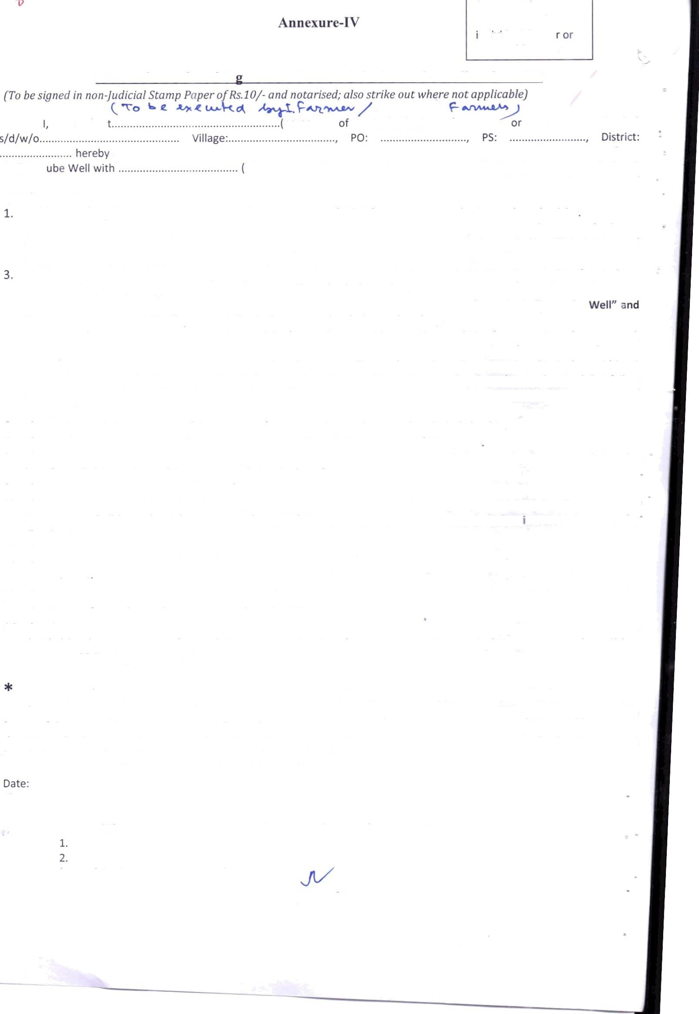Witness:

(Write full address & contact nos.)

Signatures of Farmer / members of the Group

Page 18 of 53

.4niicxurc-II .I



We. the following 10 nos. / nos. applicants have formed a cluster of ............ . (10 nos./ 30 nos.) STW with Electrir al

Pump set for availing the Provision of

(25 KVA Sub station / 63 KVA Sub station / connecti on of 3 Phase 11 KV Line with PSC Pole etc up to 1Km from the last poin1 of existing ele‹ trical power source to newly installed sub station) under RIDF.

And

We solemnly give following underI akii Jgs on ......../ /20 T8, which wilI be binding on us and any violation of these, will penaiize

us for legal action and or action as decided by the Departmen I of AgricuItUre, Assam.

1. This Under1aking is made for the purpose to develop Irrigation facilit y for increasing production and produc tivity
2. We will abide by the “Guideline for Installation of STW under Projects — “Installation of 1 Lakh Shallow Tube Well” under

RIDF”, which is annexed wi th thi . Undertaki ng

1. \/\ie declare that the total area cf our culI ivable land is 20 hectare (150 bigha) / 60 heetc re (450 bigha) for ur cluster o TO Nos./ 30 Nos. of STW and this to tal area is a cont igu ous cuItivable agricuItural land.
2. We u JdersI and thaI a premiun of Rs. 2,500.00 (Two Thousand Five Hundred) only against each STW anmounting to total Rs.25,000 / Rs.75,000 for our cbuster of 10 Nos./ 30 Nos. of STW shall have to be deposited to EE(A)/ AEE(A) as sect rity deposi I/ the excess amount show n in Annexure III A at column 4 shalI have to be deposited to APDCL through EE(A)/ AEE(A) of the Distri ct as advance paynJ‹‘nt towards ins talla tion of 25KVA / 63KVA sub-station.
3. We u nderstand and declare th aI the power drawn from the 25 KVA / 63 KVA sub sta tion by the clus tel shall be uti ised

excIusively for agriculture purpose only and no diversion of power or used otherwise shall be permitted by s

*L›.* We u‹nder stand th at District Ei lineer shalI sanction the Provisions as per site speci fic neeo on the strentI h of Pro vis.on aI SancI ion with Estima te & Demo nd Note re¢ei ved from AP DCL after submission of mon ey receipt against dvposit of ad ance (excess anJount as per Annexuro III A) payment to APDCL by us.

1. We understand that the fund for actual amounI as per Provisional Estink a te fro m APDCL, after deduction of adnance oayment made to APDCL by us. shall be provided by the DeuartmenI and this fund will be deposited to th‹ concerned ‹Office of APDCL en submis sion of . II documen ts mentioned in the Guideline by the District Engineer to the Chief Englneer Agrlcu Iture, Ass anJ
2. We shall proper Iy & ‹‘fficien tlv u tilise irr ga tion watei available front the STWs so that all the member f the clust‹ r can derive the benefit
3. We understand that any disp te between us and the Agr iculture Depar I inenI will be resolved amicably by the Director ate of Agriculture, Khanapara, Guwahati 781022.
4. We fully understand that any violation of clauses enumera ted above will penalize me/us for legal action and or action as decided by the Dep artmenI o Agriculture, Assam and put my/ our signature below in our good state of mind(s) in pr‹ sence of following witnesses.

” 11.Optional I/We like to pray for arrang ng a con tractor from the departmental approved empanelled list to exec‹. te the STVV (As apphcable) on behalfof us Furthervve pledgeto submit the beneGc ary share (applicable) in favour of the empanelled contractor in the form of Demand Draft to the District Engineer prior to execution of the work. Also the Govt. subsidy .+gainst

the completed work shall be in I ‹lvour of the empanelled con tractor based on the final bill amount for which we are not liable for any claim (required/ not reqs ired).

Date:

Place:

Signatures of Farmer / members of the Group

1

(Write full address & contact nos.)

Page 19 of 53

An nexure TV (D)

Format for Deed of A eement

(To be executed by an individual farmer to cover a command area of 2.00 ha of contiguous agricultural cultivable land for equitable distribution of water with adjacent farmer )

applied for STW wit erated pumpset for irrigation

having cultivable 1 Bipha. This agreement is hereby executed with the following neighbouring farmers to cover a command of 2 ha for irrigation.

SI. Name & Address of Participating No Adiacent Farmer

Land holding Signature

1 hereby agreed to distribute the irrigation water from the STW applied for proportionately for cultivation to the above participating farmers.

Witness

(Name and Address)

S‹gnature of Applicant

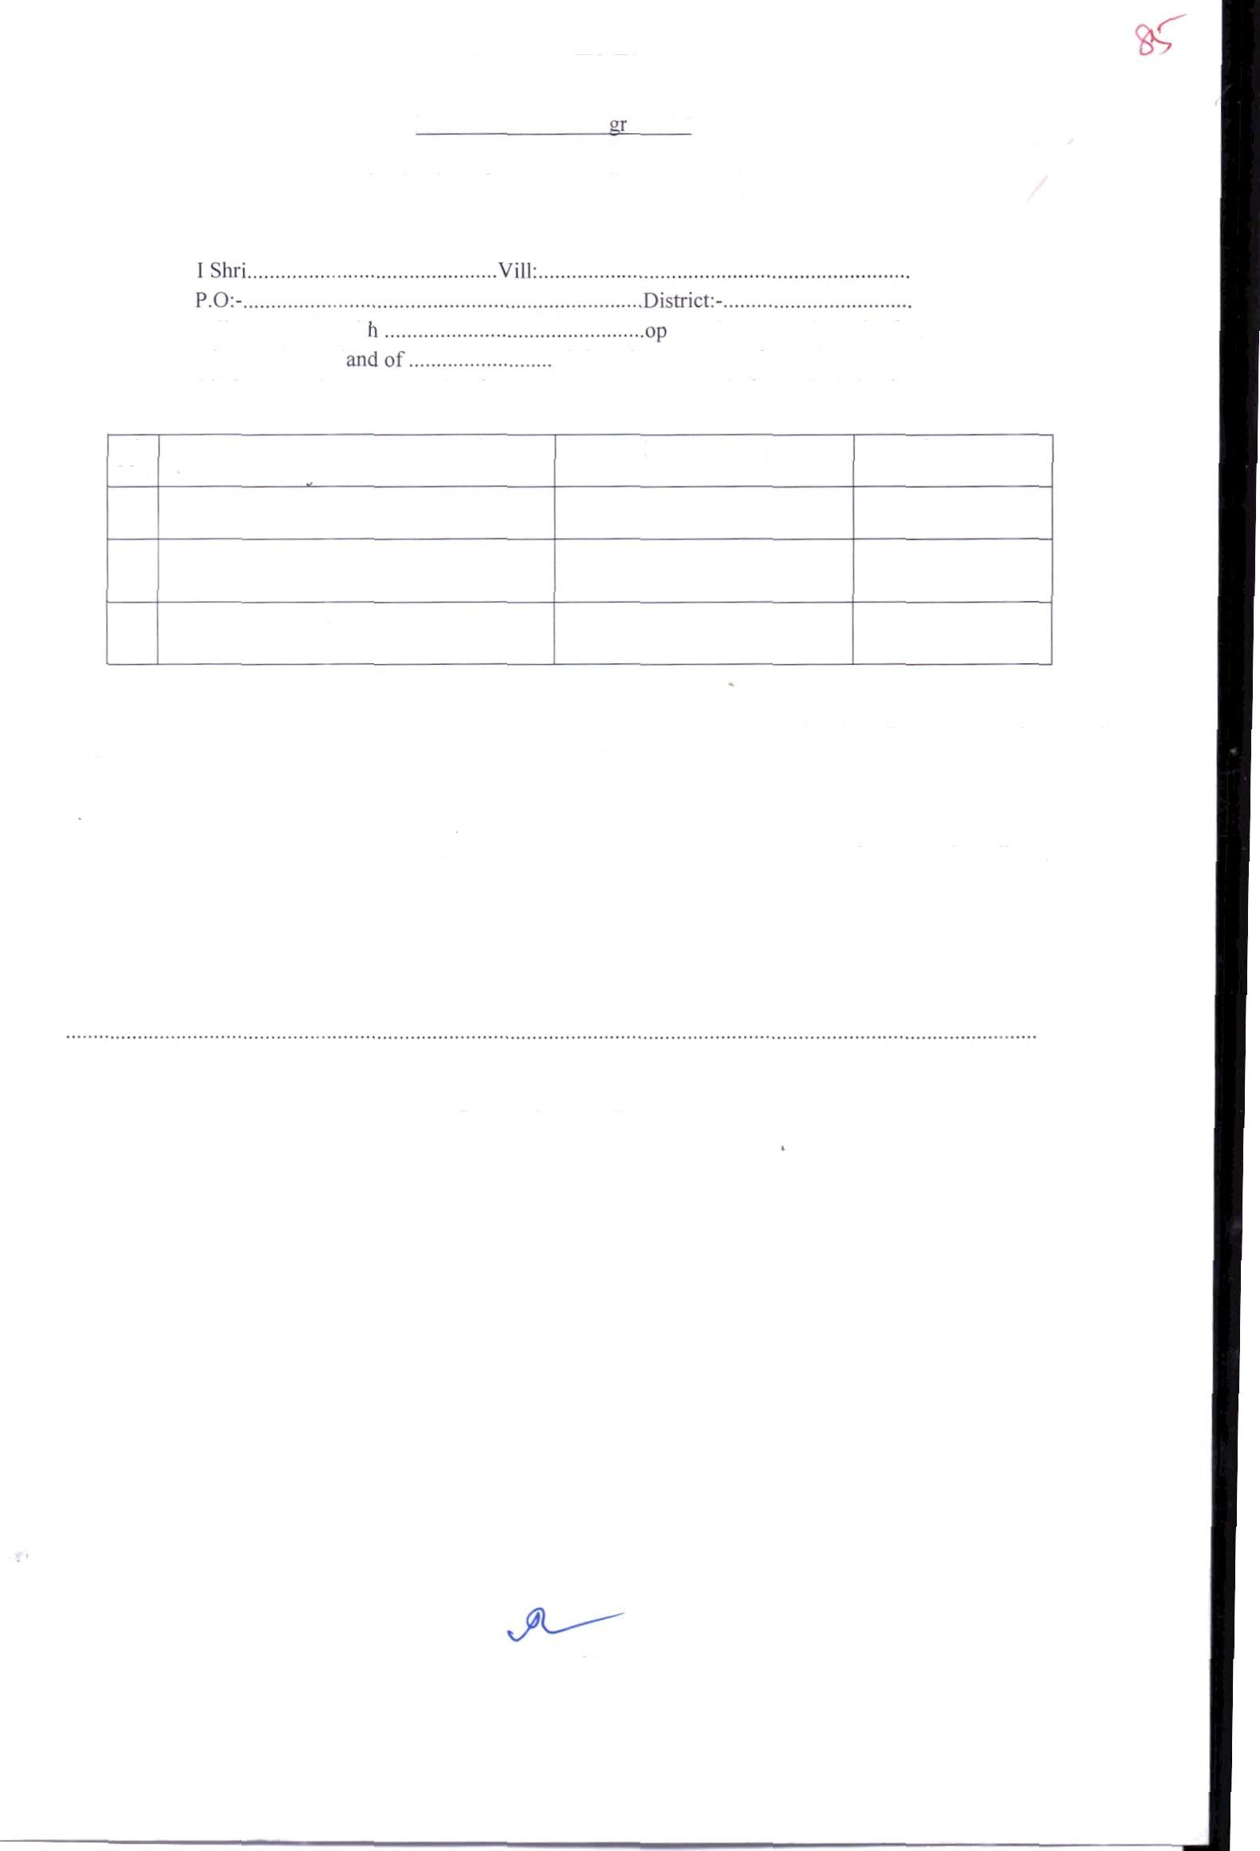

Countersignature By-

District NGO AAE/Junior Engineer

Page 23 of S3



ANNEXURE X

*Indian Standard*

DRINKING WATER-SPECIFICATION *(Second RevisionJ*

ICS 13.060.20

BIS 2012

BUREAU OF INDIAN STANDARDS

MANAK BHAVAN, BAHADUR SHAH ZAFAR MARG, NEW DELHI 110002

AMENDMENT NO. 1 JUNE 2015

IS 10500: 2012 DRINKING WATER - SPECIFICATION *\Second Revision)*

[Page 2, Table 2, SLNo. xii, col 3] - Substitute ‘1.0’ for ‘0.3’ [Page 3, Table 3, SI.No. x, col 4] — Substitute ‘no relaxation’ for ‘0.05’

SI.No. Characteristics Requirement Permissible Li it Me hod of Test Remarks

(Acceptable Limit) in the absence of Ref to

Alternate source



*(Age2) — IS 10500.* 2022

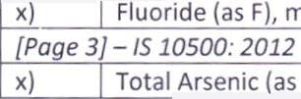

x)

Fluoride (as F), nag/I, Max

10

IS 3025 (part 60)

*(Poge 3) — IS 10500. 2012*

)x Total Arsenic (as As), mg/I, Ma 0 OF 0 05 30 5 ( r 7





Collected

* NB: The above data is based on various on going studies by different institutions in India and ab‹ oad.

Page 46 of 53